KE1V -

Functionality
It is possible to transfer planned values and quantities periodically from costing-based Profitability Analysis (CO-PA) to Profit Center Accounting. To do so, you need to assign the value and quantity fields in CO-PA to the accounts in Profit Center Accounting. You can define rules in Customizing to derive the correct account in EC-PCA.

Scenario
Transfer PA plan for 218W LLDPE to PCA. Company code 1000; and Plant 1000.

Requirements
In addition, plan data must exist for combinations of profit center, controlling area, and company code in costing-based CO-PA. Note that when no profit center is found for a posting to CO-PA, the system automatically assigns that posting to the dummy profit center. Plan data that is not assigned to a specific controlling area and company code cannot be transferred to EC-PCA.

Menu Path | Accounting → Controlling → Profit Center Accounting → Planning → Plan Data Transfer → KE1V - Costing-based CO-PA
Transaction Code | KE1V

1. Double click on KE1V - Costing-based CO-PA.

Transfer to EC-PCA: Initial screen

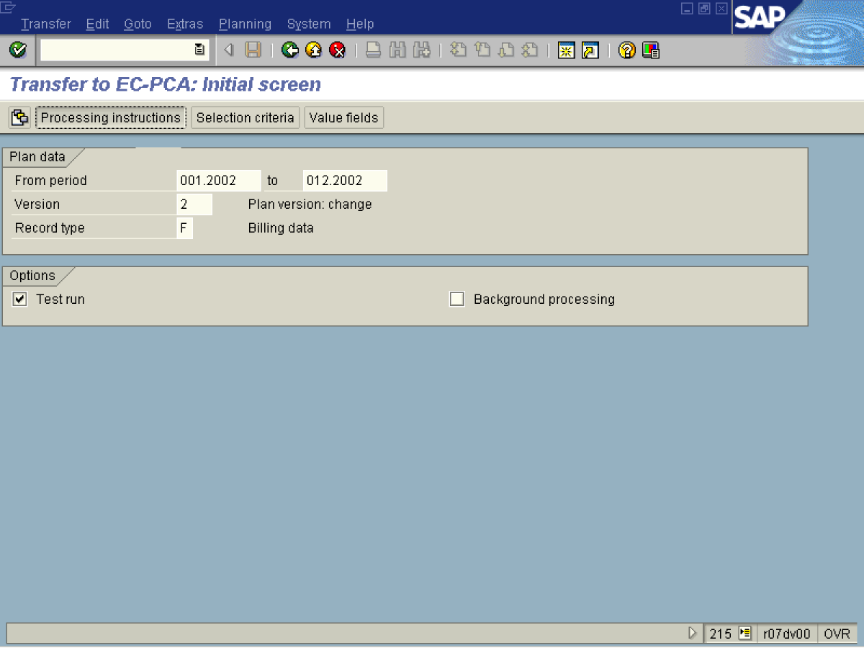

2. Update the following fields:

Field Name | Field Description | Values
From period | From Period | Example: 001.2002
To | To Period | Example: 012.2002
Version | Plan version, relevant for Co-PA planning | Example: 2
Record type | Relevant record type: billing document. | Example: F (Billing)

3. Click the Processing instructions button to select what Characteristics should be retained, and which should be summarized.

Transfer to EC-PCA: Processing instructions

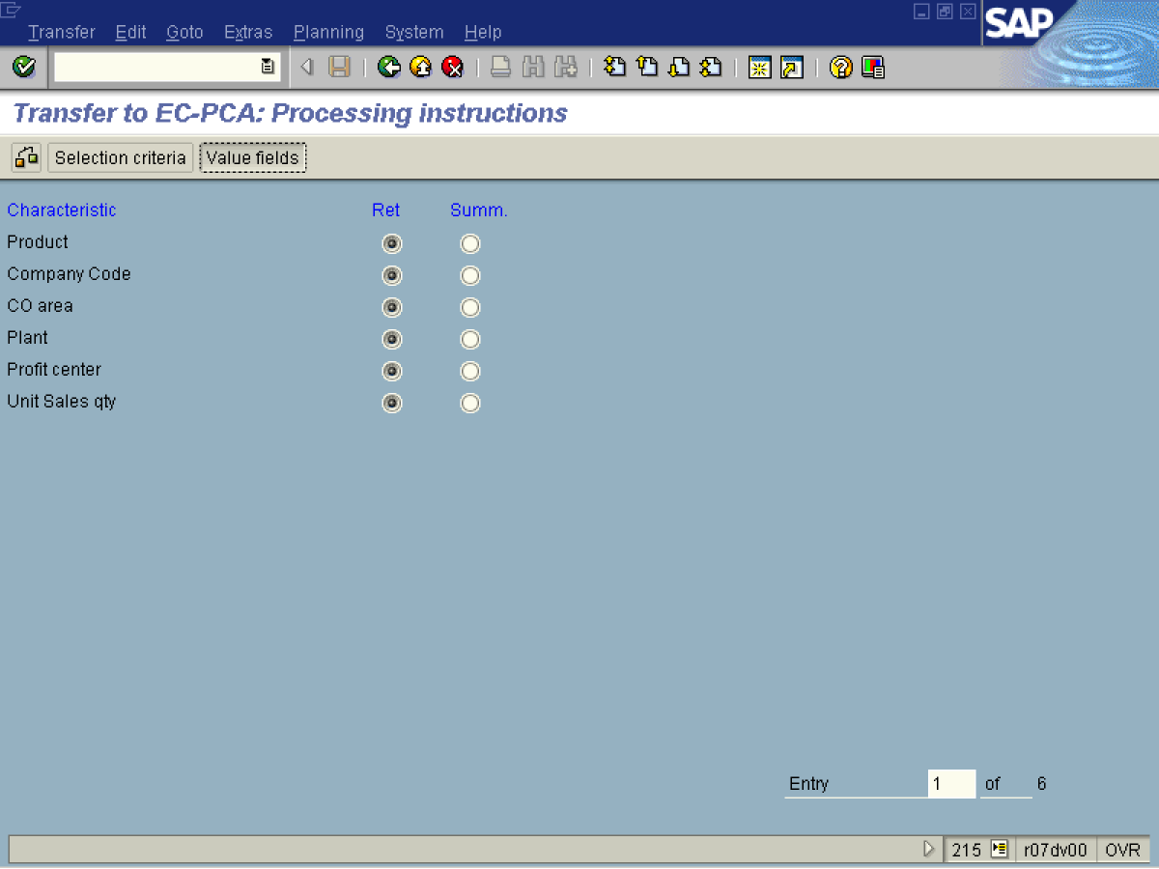

4. Click the Value fields button to select the value fields you want to transfer to PCA. Note that these value fields should have been defined in the derivation rules of the accounts numbers.

Transfer to EC-PCA: Value fields

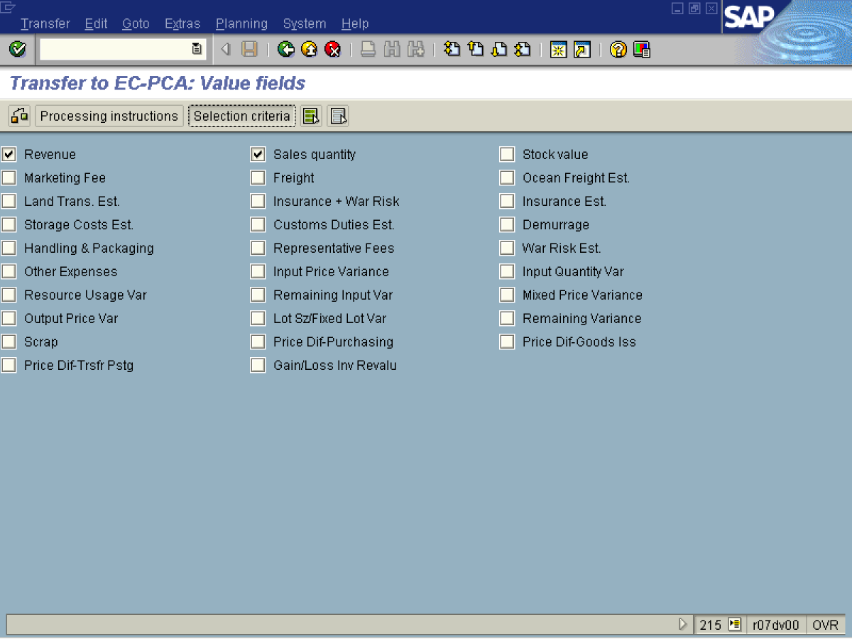

5. Click the Revenue .and the Sales quantity .checkboxes to select them.

6. Click the Selection criteria button. To select what are the criteria for the transfer.

Transfer to EC-PCA: Selection criteria

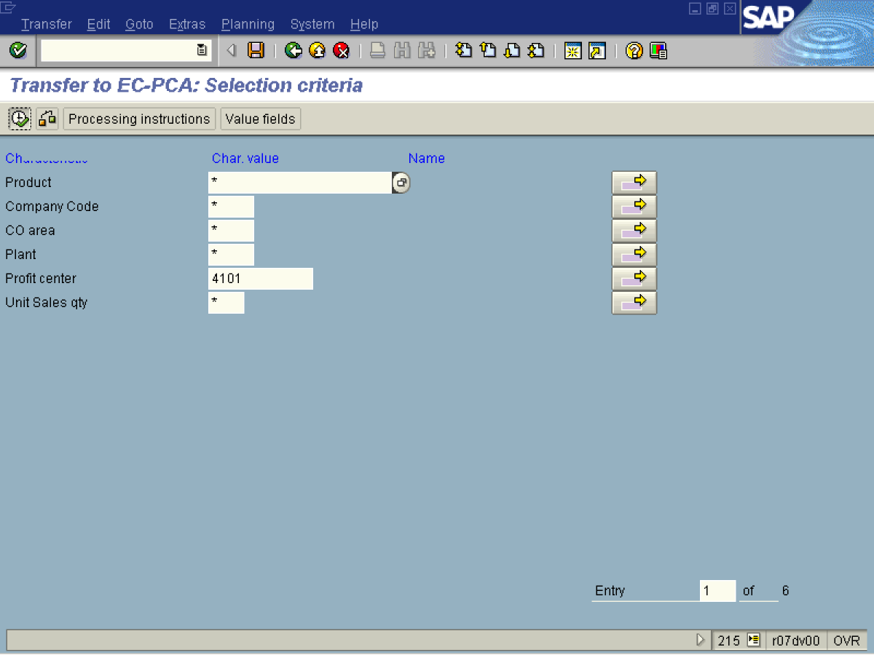

7. Update the following fields:

Field Name | Field Description | Values
Profit Center | Profit Center of the material plan to be transferred | Example: 4101

8. Click the Execute button.

Transfer to EC-PCA: Log

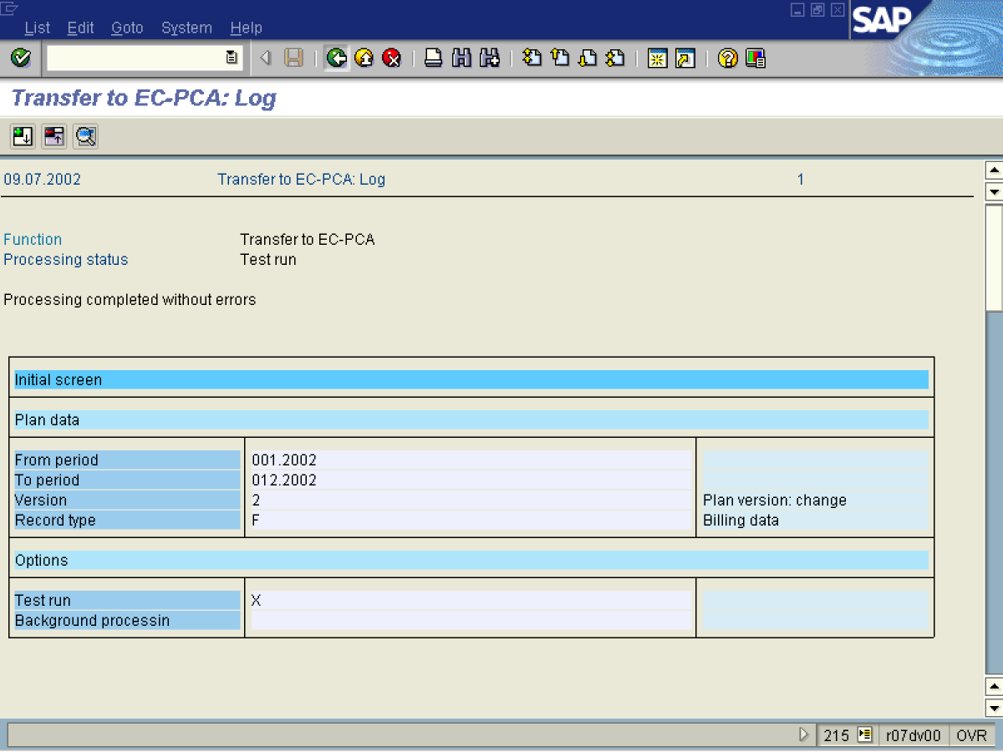

9. Click the Back button.

Transfer to EC-PCA: Initial screen

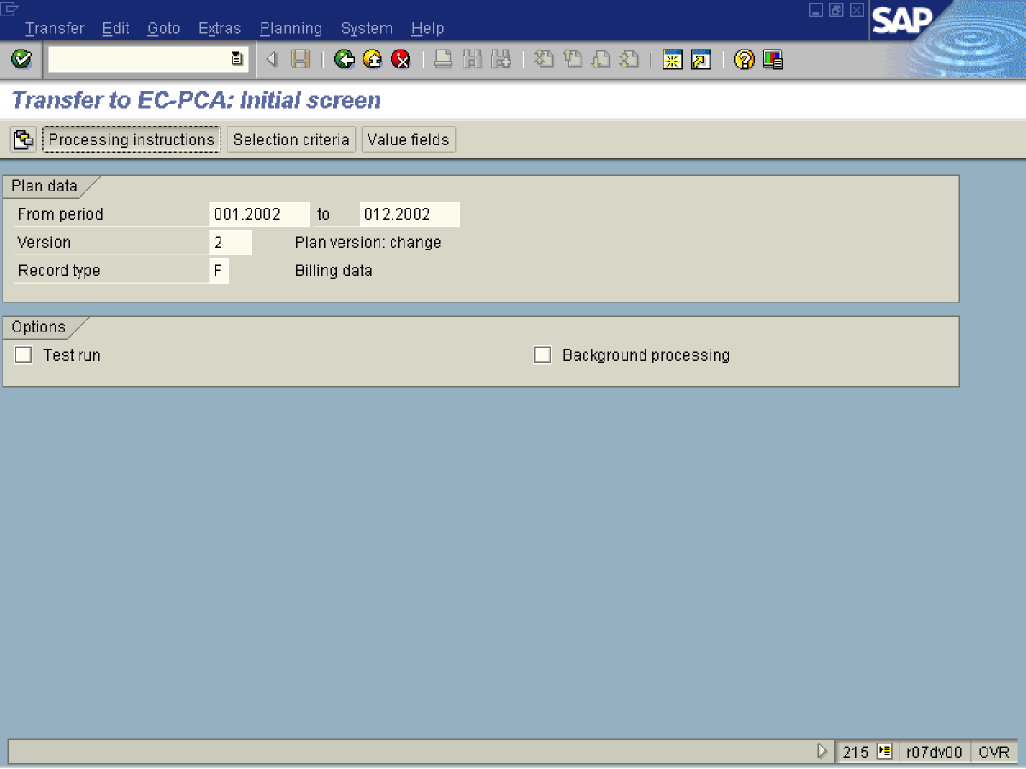

10. If you are satisfied with the results, repeat the same process in Production mode by deselecting the Test run checkbox.

11. Click the Back button to go back to SAP Easy Access screen.

